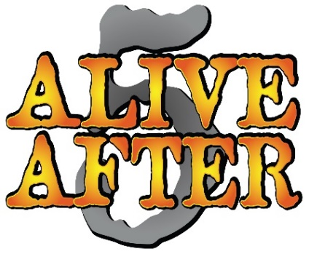
HOST APPLICATION
The Alive After 5 Summer Concert Series invites City of Elmira businesses to participate in the Alive After Five Concert Series produced by Elmira Downtown Development Inc. and presented by Chemung Canal Trust Company.
All events are presented free to the community.
Prospective establishments must complete an application and return it to the Elmira Downtown Development Office in order to be considered for participation. Applications will be reviewed and selected by the Alive After Five Committee. Extra consideration will be given to applicants that participate in “Taste of Downtown 2020”, EDD’s Annual Fundraiser for events including Alive After 5.
Restaurants, Bars and Organizations within the Business Improvement District (BID) to pay a flat fee of $1,250
those residing outside of the BID will pay a $1,350 fee.
Friday Nights Available
5:05PM – 9:00PM
May 15th, May 29th, June 12th, June 26th, July 17th, July 31st,
August 14th, August 28th, September 11th, September 25th

Application must be RECEIVED BY Elmira Downtown Development
By 5:00PM Friday, February 1st

Business name: __________________________________
Address: ________________________________________
Phone Number: __________________________________
Contact person: __________________________________

Signature: ___________________________ Date: ____________________________

PLEASE SEND:
- Completed application
- A letter stating how your organization has contributed to EDD in the past and plans to in the future
- A list with top (3) dates you would prefer September 25th is not available
- A list of (3) bands you would prefer from the list provided
-1st choice will be given to you for bands you have had in the past
Application Review process: February 1st.
All vendors contacted with results: February 15th.
Approved vendor payments and contracts due: March 1, 2020.

IF YOUR ESTABLISHMENT IS CHOSEN PLEASE SEND

- Payment in full
- Signed and Initialed contract
- Your choice of Non- Profit Organization to work beer truck for tips
- Certificate of Liability Insurance- minimum $1 million coverage naming: Elmira Downtown Development as additional insured – 311 East Water Street, Elmira, NY 14901
- Liquor License / Temporary Permit - Please submit 30 days prior
Copy EDD and Seneca Beverage on NYSLA email when you receive to: kboland@elmiradowntown.com

ESTIMATED COST BREAKDOWN OF EACH AA5 DATE:

 | EDD Expenses Per Event
Stage/Production | $ 4600.00
Ed's Heads | $ 300.00
Average Band Cost | $ 700.00
Marketing Advertising | $ 200.00
Cups/Wristbands | $ 400.00
Administration Time | $ 225.00
Security | $ 120.00
Total Event Cost | $ 6545.00
2020 Event Fee | $ 1,250.00
2020 Event Fee - Outside BID | $ 1,350.00
% of Total Costs Establishment Covers | 19%
% of Total Costs EDD Covers | 81%

